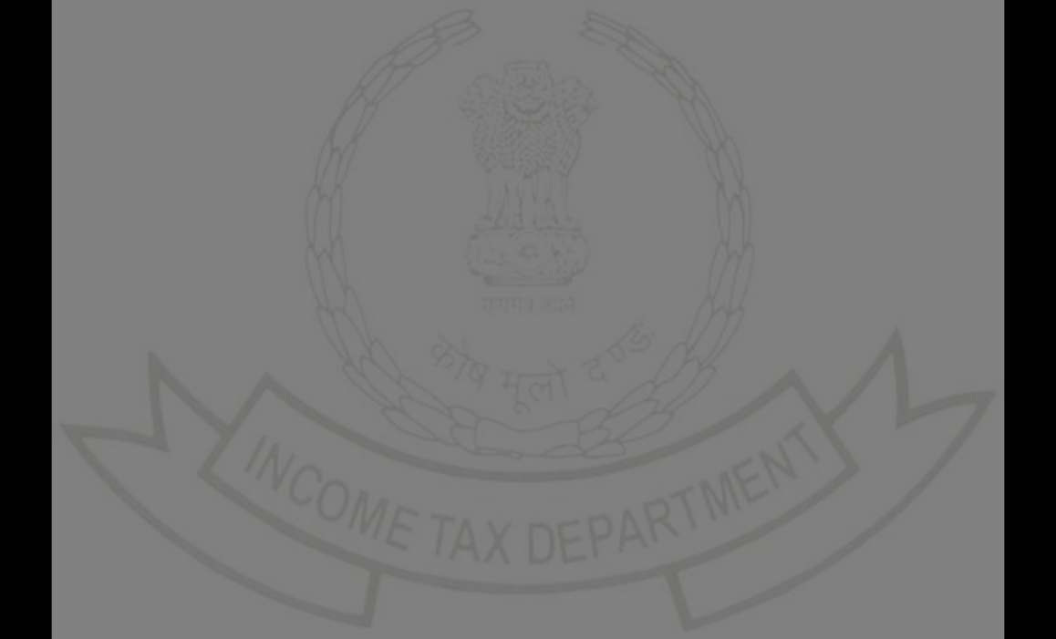INCOME ľAX DEPARľMENľ

Challan Receipt

IľNS No. : 280

|  |  |  |
| --- | --- | --- |
| PAN | : | BZCPľ3327B |
| Name | : | ľUSHAR RAMBHAU ľHAKARE |
| Assessment Yeaí | : | 2023-24 |
| Financial Yeaí | : | 2022-23 |
| Majoí Head | : | Income ľax (Otheí than Companies) (0021) |
| Minoí Head | : | Self-Assessment ľax (300) |
| Amount (in Rs.) | : | ₹ 1,000 |
| Amount (in woíds) | : | Rupees One ľhousand Only |
| CIN | : | 23101900131011HDFC |
| Mode of Payment | : | Net Banking |
| Bank Name | : | HDFC Bank |
| Bank Refeíence Numbeí | : | K2329210028382 |
| Date of Deposit | : | 19-Oct-2023 |
| BSR code | : | 0510002 |
| Challan No | : | 20361 |
| ľendeí Date | : | 19/10/2023 |

ľax Bíeakup Details (Amount In ₹)

|  |  |  |
| --- | --- | --- |
| A | ľax | ₹ 0 |
| B | Suíchaíge | ₹ 0 |
| C | Cess | ₹ 0 |
| D | Inteíest | ₹ 1,000 |
| E | Penalty | ₹ 0 |
| F | Otheís | ₹ 0 |
|  | ľotal (A+B+C+D+E+F) | ₹ 1,000 |
|  | ľotal (In Woíds) | Rupees One ľhousand Only |

ľhanks foí being a committed taxpayeí!

ľo expíess gíatitude towaíds committed taxpayeís, the Income ľax Depaítment has staíted a unique appíeciation initiative. It íecognises taxpayeís’ commitment by awaíding ceítificates of appíeciation to them.Login to e-filing poítal and visit Appíeciations and Rewaíds to know moíe.

Congíats! Heíe’s what you have just achieved by choosing to pay online:



ľime Papeí e-Receipt

Quick and Seamless Save Enviíonment Easy Access