Don’t make any changes here

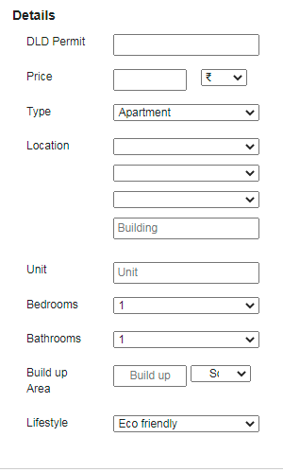

Copy all changes from the projects that we requested

In the below user should be able to select just one option (property module)

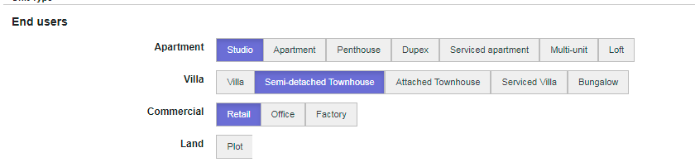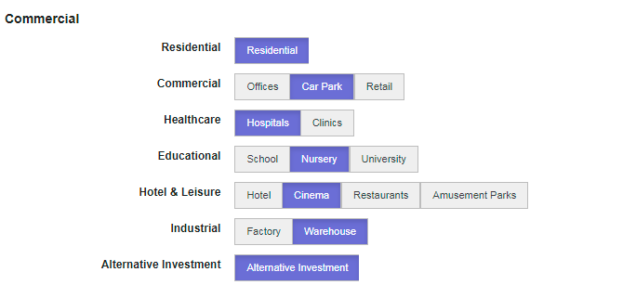

Remove this from Property module

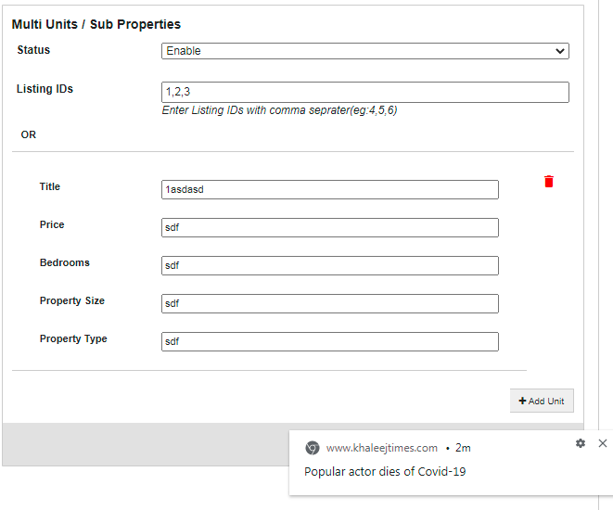

Latitude and longitude missing on the project and property module , it should be same like you did for locations , when we type the name it shows the latitude and longtitude automically

When moving from details to pricing or assignment, System to save data type earlier

In project and property both there should be an option to similar properties based on price/ bedroom/ lifestyle/ location – refer to front end design

You can remove the banks and mortgage calculator for now from front end

Also please ensure that India data doesn’t reflect any where