Hi Mk

Please see below feedback on properties pages

|  |
| --- |
| **Please add the List of Agent all user will will be** [**b@dluxuryhomes.com**](mailto:b@dluxuryhomes.com) |
| Kristina Skalicka |
| Veronika Ciniburkova |
| Stephanie Foley |
| Negin Vafaei |
| Marina Chshepetkova |
| Saab Wayne |
| Abdulrahman Murar |
| Vijay Bhatia |
| Shermon Roshan |
| Zuleykha Ablyametova |
| Aron Kujore |
|  |
| Luke Fernandez |
| Rahul Awasthi |
|  |
| **Add to the list of lifestyle** |
| Eco friendly |
| Golf |
| Lake front |
| Outdoor activity |
|  |

**Where you have active and not started can you add the below status**

Draft – this means the agent or any other user can create a listing at this stage

Content creation – this is where the SEO and content writer can edit add the listing

Active – only admin can make the listing live

SOLD / Rented - For Sales listings there should be an option as sold and rental listings rented

Archived – When listing is marked Archived it will go to the Archived page

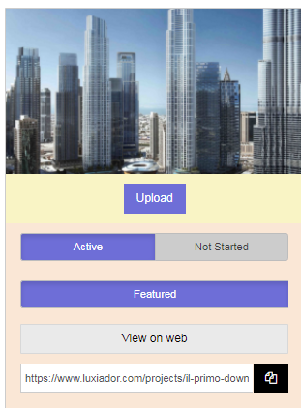

View 0n web- Doesn’t work

Rename Active to Publish | Publish means it should go live on website

Rename not started to Unpublish | UnPublish means when its just under updating stage

Add Another Option – Archive – All Archive listing should go to Archive link

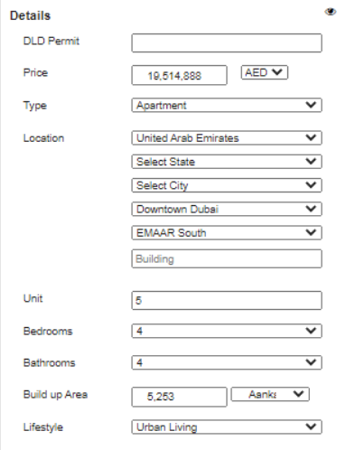

Rename Unit to Unit number. Combination of Building and Unit number should be a validation to avoid listing duplication

Also add few more fields here –

1. Title deed
2. SPA number
3. Listing Duration –This should be calculated from publish date to
4. 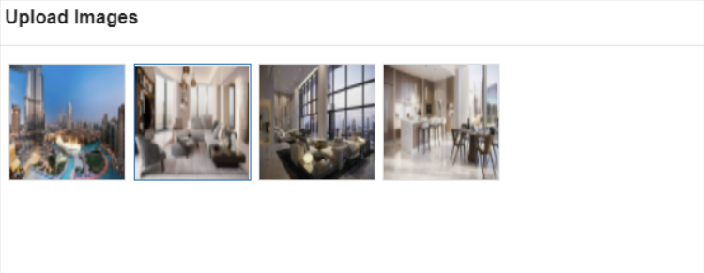

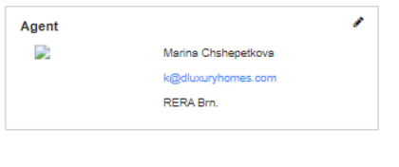

Here Agents Full name| Mobile| email| BRN should reflect



Here remove Score and All enquires for this listing should appear in this zone

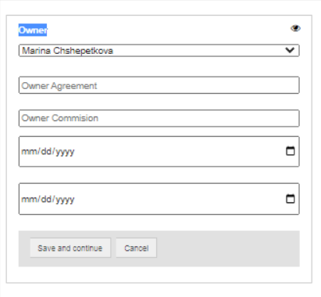

Owner details will be picked up from Contacts so for now don’t link it anywhere, we will keept his as last step. We should update this towards the end

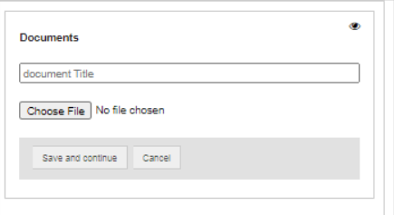

Here I just need a drop down, User should be able to add multiple documents and select a name the name of the documents form the list

Identify Proof

1. Owners passport
2. visa page
3. Emirates ID

Property Proof & POA

1) Title Deed (completed)

2) Pre-Registration Title Deed

3) Developers contract

4) NOC from Developer

5) Affection Plan

6) Power of Attorney

7) Passport copy of POA holder POA must be in Arabic and English.

8) Floor plan/floor plate/plot plan, if available.

9) Tenancy Contract.

10) Additional Documents for Leasing

11) Warranty documents

12) Maintenance agreements

Documents for company based in U.A.E

1. Copy of Trade License.
2. passport copy.
3. Power of Attorney

Documents for company based outside U.A.E

1. Proof that signatory is authorized to represent Company
2. Copy of Certificate of Incorporation
3. Copy of Memorandum and Articles of Association
4. Copy of Board Resolution
5. Power of Attorney and signatory's passport copy

-----------------------------

18th May

When you add and save documents, its should stay on the same page and not take you to details info page

The docuemnst are not getting saved

How to edit Payment plans

Can you move this section to Details section please

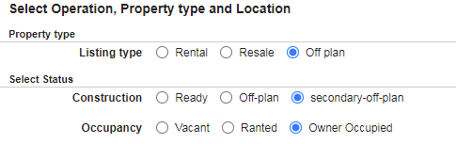

Also Add another tab her Furnish type – (radio button) – Furnished , unfurnished, Semi Furnished, white goods

Also move pricing tab after details and info

(feedback given on 28th April)

When user select Rentals – in pricing it should should show the below field

Rental period – 3 months, 6months, 9months, 12 months

Rental per Year ___________

Deposit Amount ____________

**Construction- Should not Appear when user select rental listings**

**Payment Plan should not reflect when user select rental listings**

Add a new tab in location ______Available from _____Date

Viewing Possible – Yes/ no (radio button)

When user select Sales or off plan Listings in pricing below should Appear

Sales Price ___________

Payment – only for off plan

Viewing Possible – Yes/ no (radio button)

Please don’t forget that we need a video link

Resding the feedback of 28th April again

Draft – this means the agent or any other user can create a listing at this stage

Content creation – this is where the SEO and content writer can edit add the listing

Active – only admin can make the listing live

SOLD / Rented - For Sales listings there should be an option as sold and rental listings rented

Archived – When listing is marked Archived it will go to the Archived page

Add – title deed/ SPA field – this will be a validation and not allow anyone to create duplicates

Assignment – Agreement should have two drop down – exclusive and non-exclusive

When you make featured, its should reflect on the listing that its featured

Remove full listing field

Price reduction, incase a price has been dropped – it will reflect on a page that is dedicated for all reduce price – not important

Remove off marketing or hide it for now

With all this we can wrap up the projects and properties